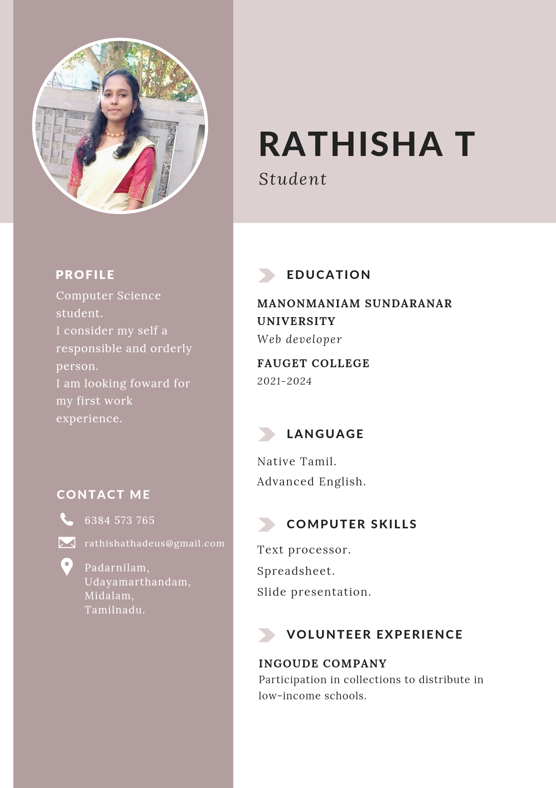

**RATHISHA T**

*Student*

**PROFILE**

Computer Science student.

I consider my self a responsible and orderly person.

I am looking foward for my first work

experience.

**EDUCATION**

**MANONMANIAM SUNDARANAR**

**UNIVERSITY**

Web developer

**FAUGET COLLEGE**

2021-2024

CONTACT ME

6384 573 765

rathishathadeus@gmail.com

Padarnilam,

Udayamarthandam,

Midalam,

Tamilnadu.

**LANGUAGE**

Native Tamil.

Advanced English.

**COMPUTER SKILLS**

Text processor.

Spreadsheet.

Slide presentation.

**VOLUNTEER EXPERIENCE**

INGOUDE COMPANY

Participation in collections to distribute in

low-income schools.